**Finding Lane Lines on the Road**

**Writeup**

The goals of this project are the following:

* Utilize Python tools including matplotlib and opencv to create a pipeline that finds lane lines on the road
* Reflect on your work in this written report

**Reflection**

**1. Description**

My pipeline consisted of multiple steps.

First, the image is converted into grayscale. Then, by setting up multiple threshold numbers, canny function is used to process the image to detect edges in the image. After that, by setting up vertices, the region of interest is being selected for further processing, which is the lane that ahead of the camera. Finally, Hough algorithm is applied to find lane lines.

In order to draw a single line on the left and right lanes, the draw_lines() function is modified. First we iterate through all the small line segments created by Hough algorithm, we calculate the mean slope, and mean coordinate for left and right lane. By using the mean coordinate and slope, we stretch the left and right lane from the bottom of the images.

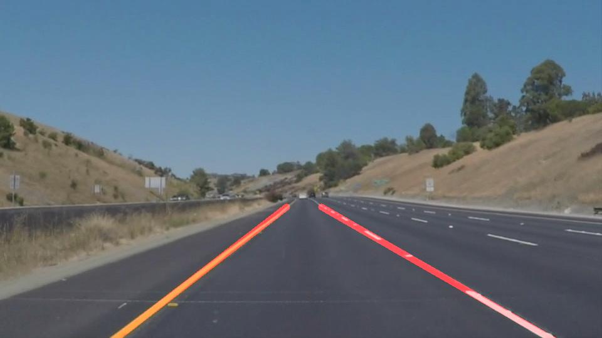

**2. Identify potential shortcomings**

The biggest shortcoming is when there is a bright obstacle on the road, for example rocks, it would interfere with our line detection. Furthermore, if the lane markings are faded, it is difficult to be recognized.

The pipeline also relies on stable sunlight and small angle road turns. For example in the optional challenge, the system is impacted by these factors.

**3. Suggest possible improvements**

Further tunes are needed for edge detection. For example, vertices and multiple threshold values need to be taken care of. Better algorithm is also needed to increase robustness for draw_lines(). Machine Learning knowledge (like linear regression) could be applied for better lane detection.